PROJECT REPORT

WITH LITERATURE SURVEY & DOCUMENTATION

Facial Recognition Attendance Manager

*Submitted in fulfilment of the requirements for the paper*

Bachelor in Technology

In

**Information Technology**

Submitted By,

|  |  |  |
| --- | --- | --- |
| Roll No | Registration No | Name |
| 16500219064  16500219055  16500219039  16500219056  16500219050 | 002046 of 2019-20  004313 of 2019-20  005507 of 2019-20  004272 of 2019-20  004848 of 2019-20 | Abir Bhattacharya  Arkamitra Mukherjee  Padma Chhatait  Anusweta Das  Basudhara Mitra |

Under the guidance of

< Ms. Tuhina Sinha >



Calcutta Institute of Engineering and Management

Department of Information Technology

Kolkata, West Bengal, India – 700040

DECLARATION

We hereby declare that the project work being presented in the project proposal entitled “Facial Recognition Attendance Manager” in partial fulfilment of the requirements for the award of the degree of **Bachelor of Technology in Information Technology** at **Calcutta Institute of Engineering and Management** is an authentic work carried out under the guidance of <Name of Project Mentor>. The matter embodied in this project work has not been submitted elsewhere for the award of any degree of our knowledge and belief.

Date: 23-10-2022

Name of Students

1. Abir Bhattacharya
2. Arkamitra Mukherjee
3. Padma Chhatait
4. Basudhara Mitra
5. Anusweta Das

Signature of Students

1. ________________________________
2. ________________________________
3. ________________________________
4. ________________________________
5. ________________________________

Abstract

An attendance system is a smart way of keeping track of attendances of a bunch of individuals. Previously when there was no computer attendances were kept using an attendance register which was obviously a hard copy. With the revolution in technology attendance management became easier as well. Software like Ms Excel, Google Sheets and other spreadsheets became popular ways of managing attendance. Later on came several other software which incorporated the working of a spreadsheets into a database table.

Introduction

A facial recognition system is a system which is capable of detecting a human face from a given image or video. It primarily works by detecting facial landmarks on a face and comparing it with the predefined landmarks of an image in the database. [1]

Broadly the Steps of Facial Recognition can be classified into four parts:

1) Representing the Image on a 2D graph: This is the first step of any kind of Image Processing, and so is the case for Facial Recognition.

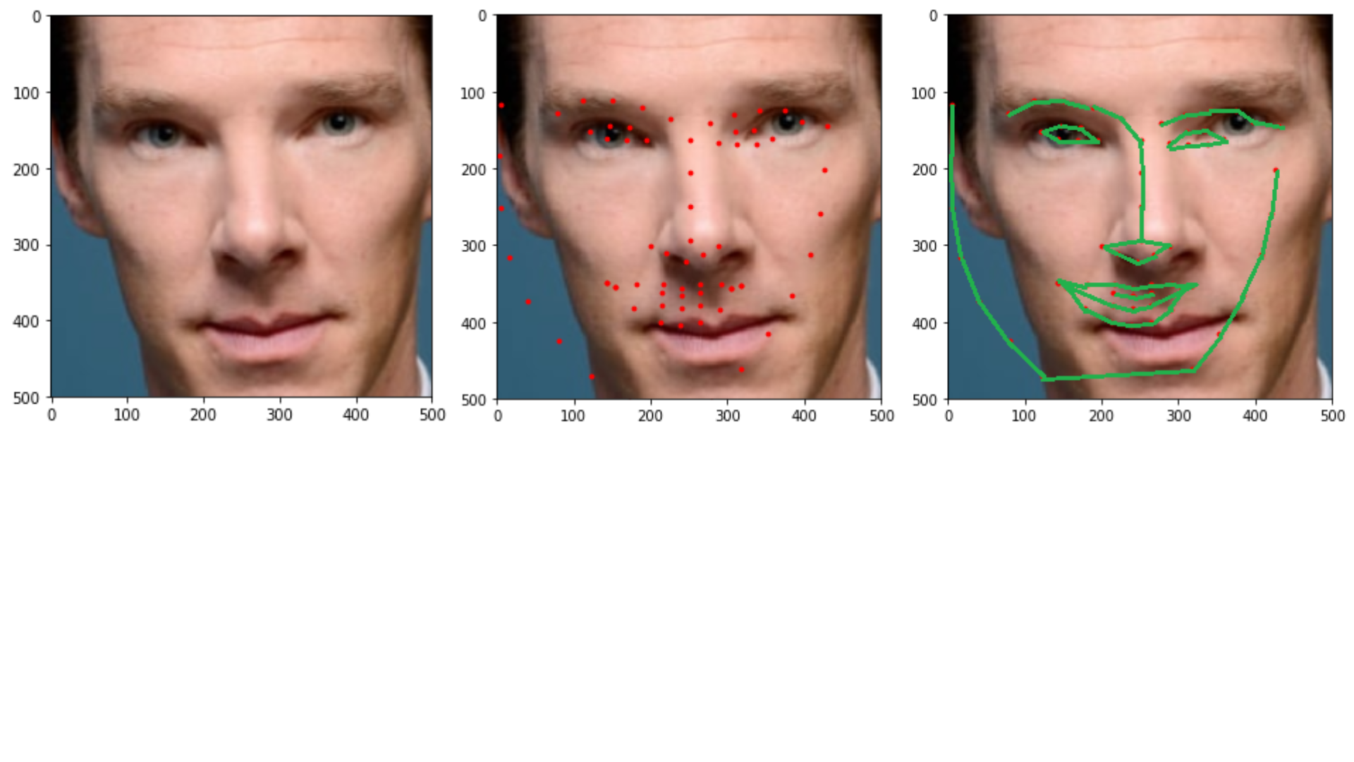

[2] Actual Image

2) Detecting Landmarks: Landmarks are determined by the help of predefined features. In case of a Human Face the features include nose, eyes, lips etc. However identifying these features is completely based on a set of dataset which is containing values in the form of a 2D matrix defining how a human facial feature would generally look like.



[2] Image with Landmarks

3) Generating Blueprint of Face: The Blueprint of a face is generated by connecting the dots of the landmarks generated in the previous step. This blueprint is unique for each human being except identical twins in some cases.



[2] Blueprint of the Image

4) Comparison: The Last step of Facial Recognition is comparing it with an already present blueprint in the database. In this case the generated blueprint will be checked with all the other blueprints in the database and find the closest match possible. Most of the times a matching accuracy of more than 70-80% is the result. Once the blueprints are matched the respective name of the person is the answer whose face it is.

Aims and Objective

The following are the Aims and Objectives for the project:

1. Login portion for the Teacher who is going to give attendance.
2. Uploading of the Image of the class taken during the class.
3. Detecting all the face present in the class.
4. Identifying the student’s faces who belong to that class.
5. Submitting the attendance for those student in the database.

Literature Review

Facial recognition is a way of identifying or confirming an individual’s identity using their face. It is a category of [biometric security](https://www.kaspersky.com/resource-center/definitions/biometrics).  The technology is mostly used for security and law enforcement, though there is increasing interest in other areas of use. The technology is used for a variety of purposes. These include:

1. **Unlocking phones**

Various phones, including the most recent iPhones, use face recognition to unlock the device. The technology offers a powerful way to protect personal data and ensures that sensitive data remains inaccessible if the phone is stolen. Apple claims that the chance of a random face unlocking your phone is about one in 1 million.

### Law enforcement

Facial recognition is regularly being used by law enforcement. According to this [NBC report](https://www.nbcnews.com/news/us-news/how-facial-recognition-became-routine-policing-tool-america-n1004251), the technology is increasing amongst law enforcement agencies within the US, and the same is true in other countries.

### Airports and border control

Facial recognition has become a familiar sight at many airports around the world. Increasing numbers of travellers hold biometric passports, which allow them to skip the ordinarily long lines and instead walk through an automated ePassport control to reach the gate faster. Facial recognition not only reduces waiting times but also allows airports to improve security.

### Banking

Biometric online banking is another benefit of face recognition. Instead of using one-time passwords, customers can authorize transactions by looking at their smartphone or computer. With facial recognition, there are no passwords for hackers to compromise. If hackers steal your photo database, 'liveless' detection – a technique used to determine whether the source of a biometric sample is a live human being or a fake representation – should (in theory) prevent them from using it for impersonation purposes. Face recognition could make debit cards and signatures a thing of the past.

**Previous works on facial recognition system:**

* **Amazon** previously promoted its cloud-based face recognition service named **Rekognition** to law enforcement agencies.
* **Apple** uses facial recognition to help users quickly unlock their phones, log in to apps, and make purchases.
* **British Airways** enables facial recognition for passengers boarding flights from the US. Travellers' faces can be scanned by a camera to have their identity verified to board their plane without showing their passport or boarding pass.
* **Facebook** began using facial recognition in the US in 2010 when it automatically tagged people in photos using its tag suggestions tool. The tool scans a user's face and offers suggestions about who that person is.
* **Google** incorporates the technology into **Google Photos** and uses it to sort pictures and automatically tag them based on the people recognized.
* **Snapchat** is one of the pioneers of facial recognition software: it allows brands and organizations to create filters which mould to the user’s face — hence the ubiquitous puppy dog faces and flower crown filters seen on social media.[5]

**How Facial Recognition Attendance System is Different from previous works :**

* All the previous facial recognition systems were able to recognize one face at a time but this system can recognize multiple faces at a time. User needs to click a picture of a class and using this system each face will be matched from database and if matched that particular student will be marked as present and if any student doesn’t belong to that particular class (i.e. checked from database) then it’ll also identify that.
* For all the previous facial recognition system a particular software needs to be installed in system but for this no need to install any software only by using the website link the system can be easily used for face recognition.

Methodology

Facial Recognition Attendance Management is capable of identifying individual faces from an image including a group of people with different faces. In this way we can generate a list of student present in a class by taking images of the class from 2-3 angles. Once the list of students is generated their attendances can be allotted in a databases by making a POST API call.

For the working of this system no other software is needed to be installed because the entire process can be implemented on a website.

Thus Technologies which will be required for this project are:

1. Mongo DB (For recording student attendances persistently)
2. Node.js (For making the APIs needed for this project)
3. HTML (For frontend scripting of the website)
4. CSS (For styling the frontend)
5. Vanilla JavaScript (For making the API calls)

Other open source services used:

1. face-api.js by Vincent Muhler [3]
2. Cloudinary [4]

References

[1] <https://en.wikipedia.org/wiki/Facial_recognition_system>

[2] <https://medium.com/ml-everything/how-facial-recognition-works-part-2-facial-landmarks-72f1b0e2a33a>

[3] <https://justadudewhohacks.github.io/face-api.js/docs/index.html>

[4] <https://cloudinary.com/>

[5] https://www.kaspersky.com/resource-center/definitions/what-is-facial-recognition